Basket

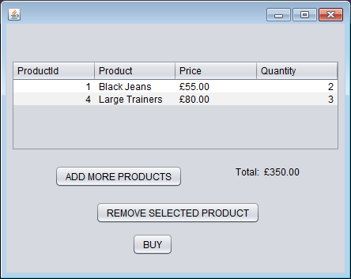

Confirmation

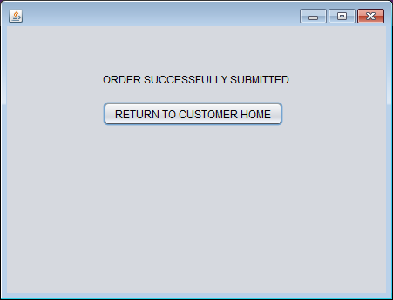

**N.B. At this stage only a logged in customer can still view and use the shop**

You should also be able to Remove From your order at this stage